# Software Project Management and Quality Assurance

## Practical – 3

Activity Precedence Table:

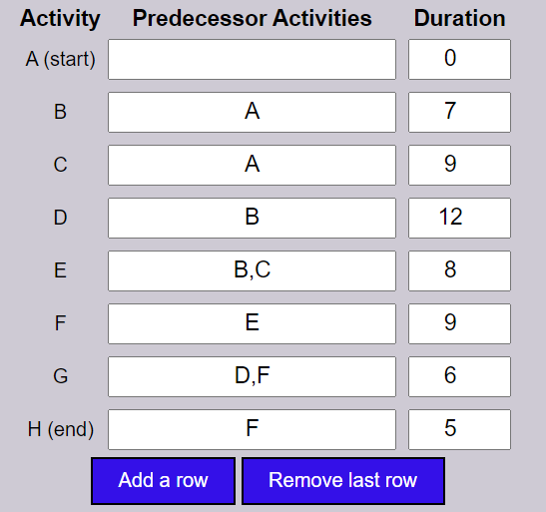

Critical Path Method (CPM) Graph:

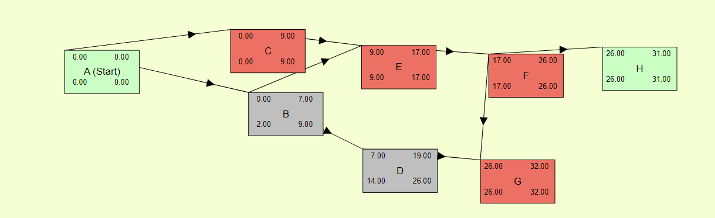

Program Evaluation Review Technique (PERT) Graph:

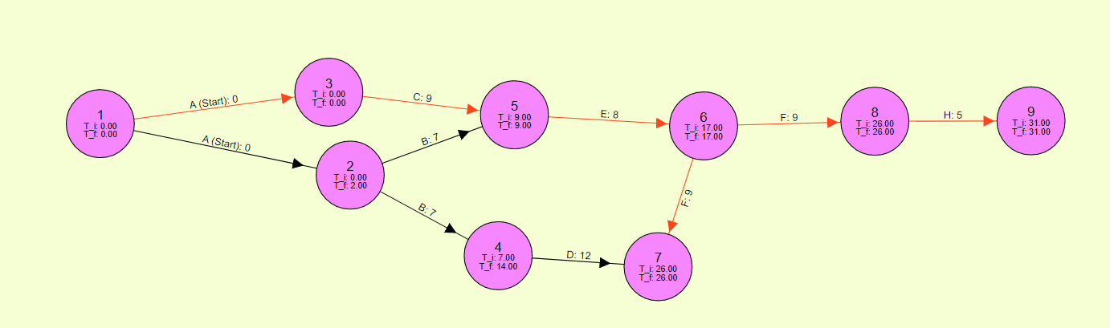

Activity Precedence Table:

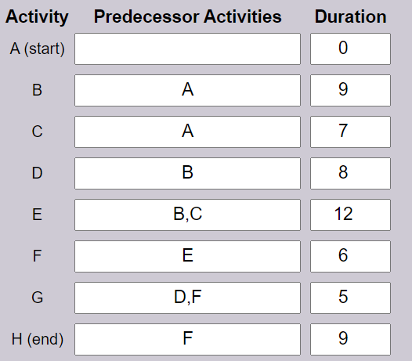

Critical Path Method (CPM) Graph:

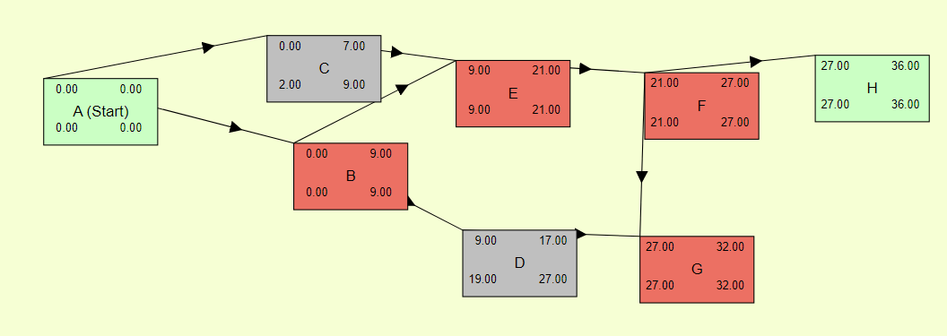

Program Evaluation Review Technique (PERT) Graph:

